SunSmart behaviours at school.
Sun protection is everyone’s responsibility.

1: SunSmart behaviours at school

PowerPoint presentation targeted at teachers.

2: Sun protection is everyone’s responsibility

Here in Australia, sun protection needs to be everyone’s responsibility.

We experience some of the highest levels of UV radiation in the world, so if we want today’s children to have a healthy future, we need to equip them with good sun protection habits now.

3: 2 in 3 image

Australia has the highest rate of skin cancer in the world.

Two in three people who grow up here will be diagnosed with some form of skin cancer in their lifetime.

Overexposure to ultraviolet (UV) radiation is the main cause of skin cancer.

4: What is UV?

UV is a form of energy emitted from the sun and some artificial sources such as solariums.

The strength of UV depends on many factors including:
- time of day—the higher the sun is in the sky, the higher the UV level
- amount of cloud cover— UV levels are highest under cloudless skies
- geographical location— the closer to the equator you are, the higher the UV is
- altitude—UV increases at higher altitudes
- extent of reflection
- extent of shade

5: Ultraviolet radiation vs infrared radiation

Unlike the sun’s light that we can see or the sun’s heat that we feel, UV cannot be seen or felt, so it can be doing us damage without us knowing!

6: UV in Australia

This is the UV levels at noon on a clear-sky day, averaged across 12 months of the year. As you can see, the UV levels are in the high + range for most of the country.

In South Australia, we experience UV radiation levels high enough to damage unprotected skin most months of the year. This means that even in winter, if children are in the playground, or when school staff are on playground duty, we’re all at risk.

7: The UV Index

The UV Index tells us how much UV is present on a scale from 0 (low) (e.g. at night) to 11+ (extreme). Higher levels indicate a greater risk of skin damage occurring in a shorter amount of time.

For most Australians damage occurs from UV 3 and higher but for those who work outdoors, even a small amount of UV can be damaging as they are exposed more frequently, and damage is cumulative!

8: 95-99 per cent of skin cancers are preventable

But it’s not all bad news. We know that 95-99 per cent of all skin cancers are directly related to our UV exposure; this means that when we protect our skin, we reduce our risk. A clear reason to make our SunSmart behaviours part of our routine at school.

9: Why schools are a priority setting

There is clear evidence that minimising UV exposure during the first 15 years of life can significantly reduce the risk of children developing skin cancer in later life.

As children attend school during peak UV times, we can play an important role in reducing future skin cancer rates by:
- creating a sun-safe environment for our students and staff; and
- helping our students create good sun protection habits through education and role modelling.

10: SLIP, SLOP, SLAP, SLIDE, SEEK shade

We encourage sun protection behaviours in Terms 1, 3 and 4 and whenever the UV reaches 3 and above at other times.

The easiest way to protect children’s skin from UV and ourselves is to:

SLIP on clothes that cover the arms and legs
SLOP on SPF 30 or higher broad-spectrum water-resistant sunscreen and reapply every two hours
SLAP on a broad-brimmed hat or one that covers the head, face, neck and ears
SEEK shade, particularly over the middle part of the day when UV is highest
And SLIDE on close fitting sunglasses

We should encourage and role model this behaviour because we know it works.

11: SunSmart App

We can check how high the UV is with the free SunSmart app.

The SunSmart app tells you the times during today when you need to be SunSmart for your location -when the UV level is 3 or above.

The app also tells you what the UV is at that time so when possible, you can avoid being in the sun at the times when UV is highest.

You can download the app by searching “SunSmart” into the App Store for iPhone or Google play for Android.

12: SunSmart hats are essential
A SunSmart hat is one of the easiest and most effective forms of sun protection in the school environment, and therefore are key when it comes to protecting children and ourselves.

The children at our school have their faces exposed to damaging UV radiation every day. Ears, temples, lips and the nose are among the most common parts of the body where skin cancer develops later in life.

And the sun’s rays don’t just damage skin—they can cause permanent damage to the eyes as well. A SunSmart hat can reduce the amount of UV radiation reaching a child’s eyes by 50 per cent.

So, if they’re not wearing a SunSmart hat? “No hat, play in the shade.”

13: What is a SunSmart hat?

What is a SunSmart hat?

SunSmart hats are broad-brimmed, bucket and legionnaire-style hats. They protect the face, back of the neck, ears and eyes.

Baseball caps and sun visors are not SunSmart because they don’t protect the ears, cheeks or back of the neck.

By having SunSmart hats in our playground, we’ll show the school community our commitment to keeping children safe.

14: How to get kids to wear SunSmart hats

When it comes to encouraging SunSmart behaviours, successful schools engaged students with “Motivation, Access and Triggers” – the M.A.T. model.

This M.A.T. model is based on the assumption that the more ways a school can support SunSmart hat wearing, the more likely it is that SunSmart hat wearing will occur. When it comes to engaging kids, there are a few proven steps we can take.

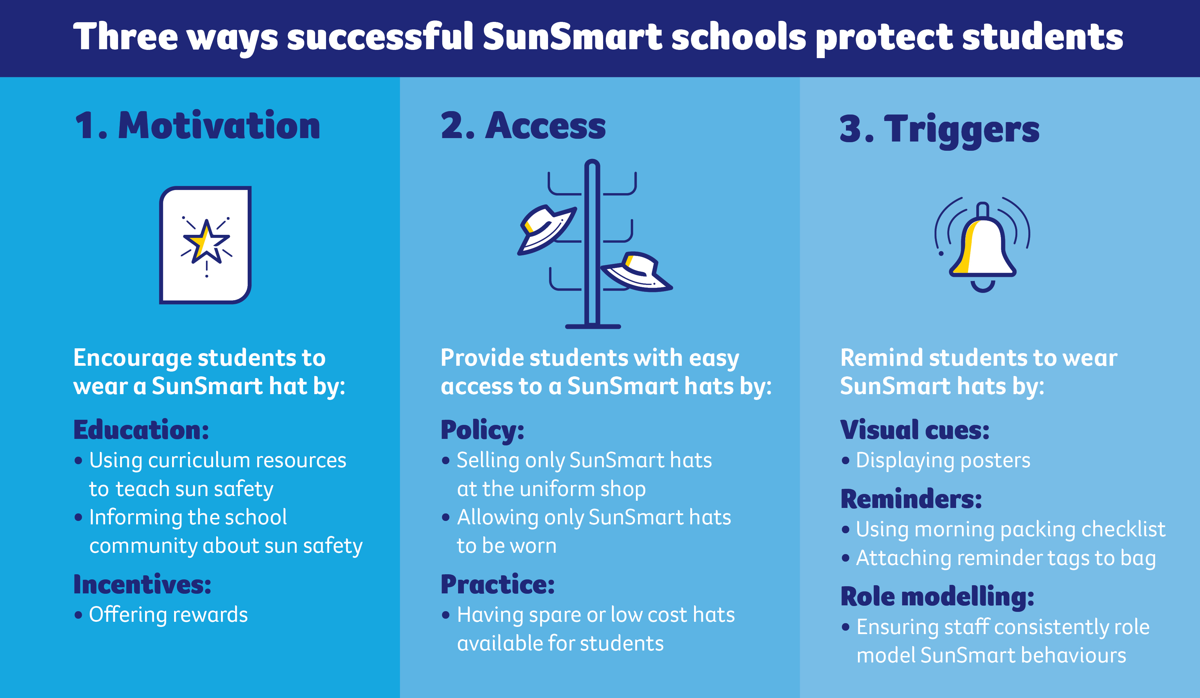

Firstly, Motivation. We encourage SunSmart hat wearing by educating our students and ourselves.

Next we come to Access. Every student should have access to a SunSmart hat.

Last are Triggers. We need to remind students and teachers to wear their SunSmart hats every day.

15: Our plan

After looking at what we currently do in our school, the leadership team and I have come up with a plan to help us reach our SunSmart goals, using resources from the SunSmart Hat-Wearing Toolkit.

[Insert Plan here. Please talk about your approach and what resources you will use at the school, which you will have decided when you completed your action plan]

We need to ensure that we are good role models and Hat Heroes ourselves because sun safety is everyone’s responsibility.

16: Motivation resources

We can use the ‘Motivation’ resources to educate and motivate the whole school community about UV, skin cancer and the importance of creating good sun protection habits.

17: Access resources

We can use the ‘Access’ resources to help address common barriers to SunSmart hat wearing or educate and persuade the governing council to look at funding options for SunSmart hats..

18: Trigger resources

We can also display these posters around the school to help remind and encourage students and teachers to put on a SunSmart hat before heading outdoors.

The full toolkit of resources can be accessed online at: (add SA website link)

19: Be a SunSmart role model

As teachers, one of the best things we can do to reinforce these sun protection habits is to be a SunSmart role model.

Our students look up to us. By being role models ourselves and leading the way with our own sun safety, we can inspire our students every day to be SunSmart when they step outside.

Not only will you be protecting yourself from harmful UV radiation, you will also be helping children in your care develop good sun protection habits for life.

It starts with Slip, Slop, Slap, Seek and Slide.

20: Thank you

Thank you.

For more information, contact SunSmart
Email: sunsmart@cancersa.org.au
Phone: (08) 8291 4265

21: Additional slides

22: SunSmart policy

As a school, we are responsible for creating a sun safe environment for our students and staff.

Implementing a sun protection policy that addresses the key areas listed on the slide can help ensure that we are doing what we can to reduce the future risk of skin cancer.

23: Tips for scheduling outdoor activities

Where possible, schedule outdoor activities (assemblies, sport etc.) earlier in the morning or late afternoon to avoid peak UV times. Peak UV times are around solar noon, this is when the sun is the highest in the sky.

Some schools have even swapped their breaks so the longer lunch break starts earlier in the morning, and the shorter recess break is done later in the afternoon.

24: Tips for scheduling outdoor activities

When planning events, consider shaded and indoor venues to minimise time in direct sun.

When scheduling outside of peak 'UV' hours 'if' not possible for certain events (e.g. swimming carnivals), be prepared by checking the UV forecast for the day with the SunSmart app and making sure that sun protection practices are planned, organised, understood and available.

25: Applying sunscreen

Cancer Council encourages staff and students to apply SPF 30 or higher broad-spectrum water-resistant sunscreen before going outdoors, and to reapply every 2 hours when outdoors for extended periods.

For more information on sunscreen refer to Cancer Council SA's Fact Sheet on Sunscreen.

